Sample Seller and Inventory Records

Objective
The objective of this submission is to insert new sample seller and inventory records into the existing ShopEaseDB database.

Select Database
USE ShopEaseDB;

Sample Seller Records – Updated
The following new seller details are inserted into the Seller table.
INSERT INTO Seller
(Seller_Name, Phone, Email, Address)
VALUES
('Nova Electronics', '9876543220', 'nova@gmail.com', 'Chennai'),
('Prime Traders', '9876543221', 'prime@gmail.com', 'Madurai'),
('Urban Choice', '9876543222', 'urbanchoice@gmail.com', 'Coimbatore'),
('NextGen Supplies', '9876543223', 'nextgen@gmail.com', 'Trichy');

View Seller Records
SELECT * FROM Seller;
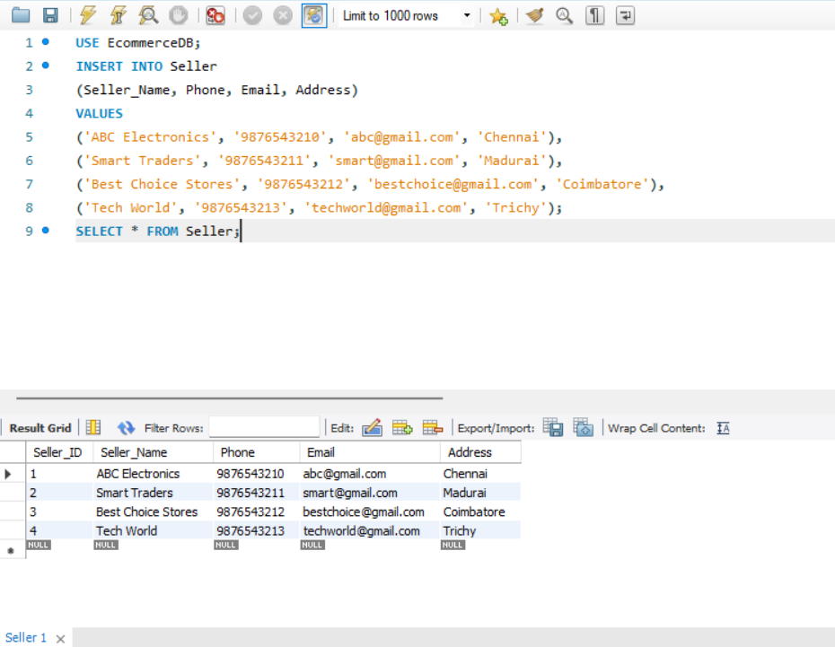

Sample Inventory Records – Updated
The following inventory records are inserted using the existing products in the Product table.
INSERT INTO Inventory
(Product_ID, Seller_ID, Quantity, Last_Updated)
VALUES
(1, 1, 32, '2026-09-20'),
(2, 2, 18, '2026-09-20'),
(3, 1, 65, '2026-09-20'),
(4, 3, 48, '2026-09-20'),
(5, 4, 22, '2026-09-20');
View Inventory Records
SELECT * FROM Inventory;
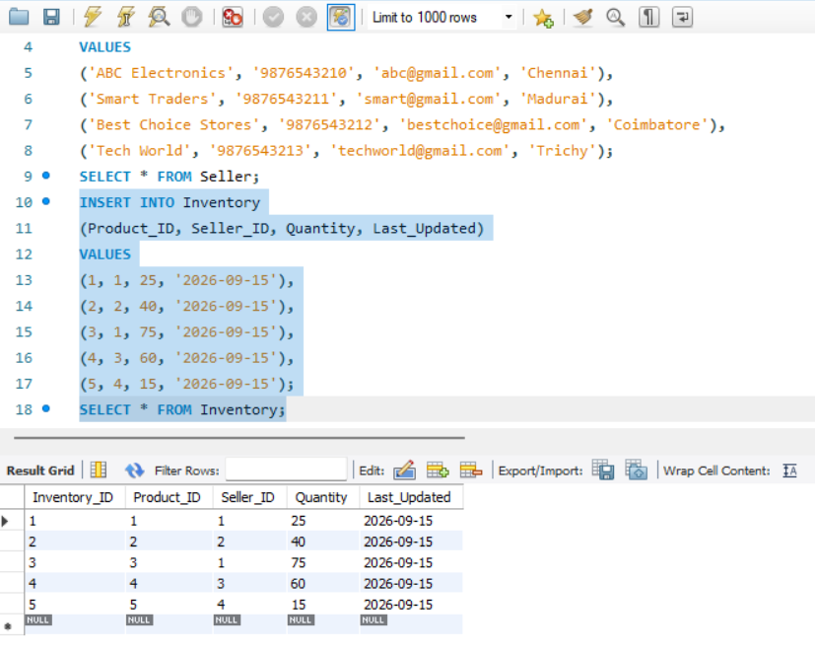 Result
The new seller and inventory records were successfully inserted into the ShopEaseDB database. The tables are ready for CRUD operations and inventory analysis.

